40.59: a) At the turning points 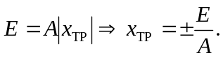
b) 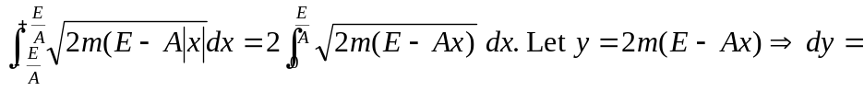
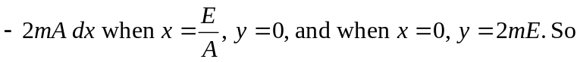
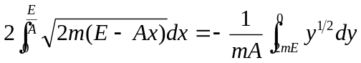
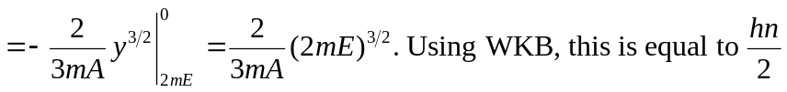.
So, 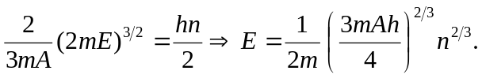
c) The difference in energy decreases between successive levels. For example:
• A sharp step gave ever-increasing level differences 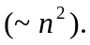
• A parabola
• Now, a linear potential
Roughly: If the curvature of the potential (~ second derivative) is bigger than that of a parabola, then the level differences will increase. If the curvature is less than a parabola, the differences will decrease.

